Go to t code LSMW
Eg: deleting current std price/PP1 price
Give project, subproject and object name
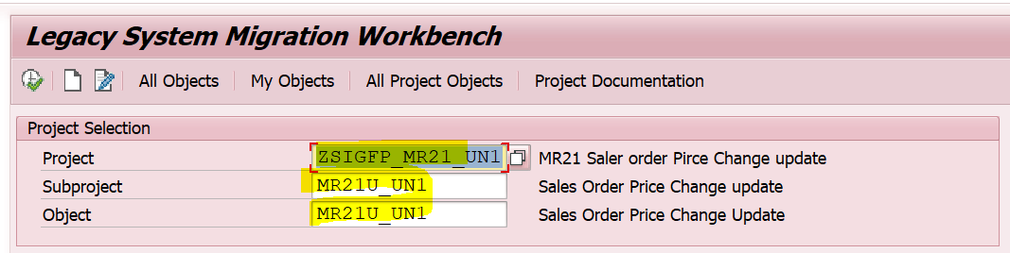
Execute
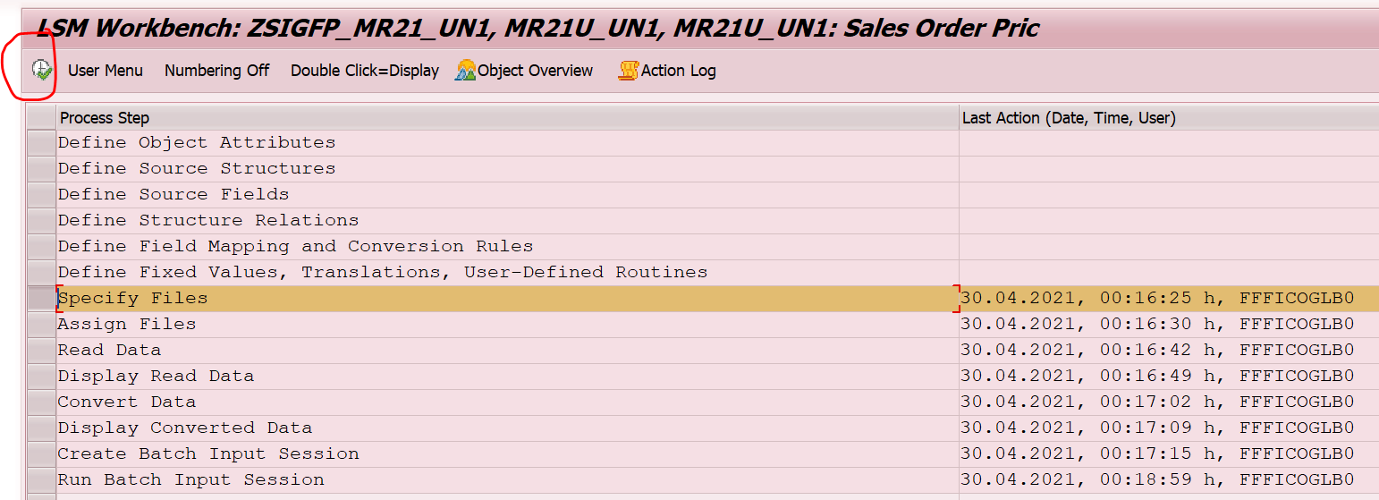
Select specify files and execute
Got to change mode
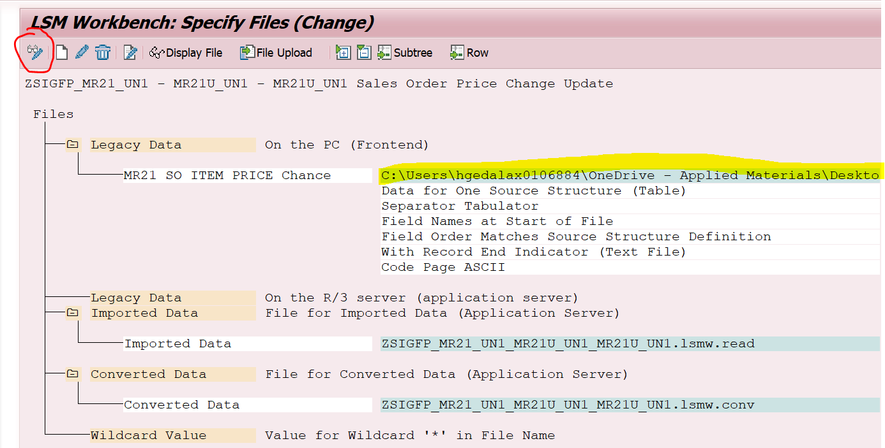
Double click on above highlighted line
Select our file from below
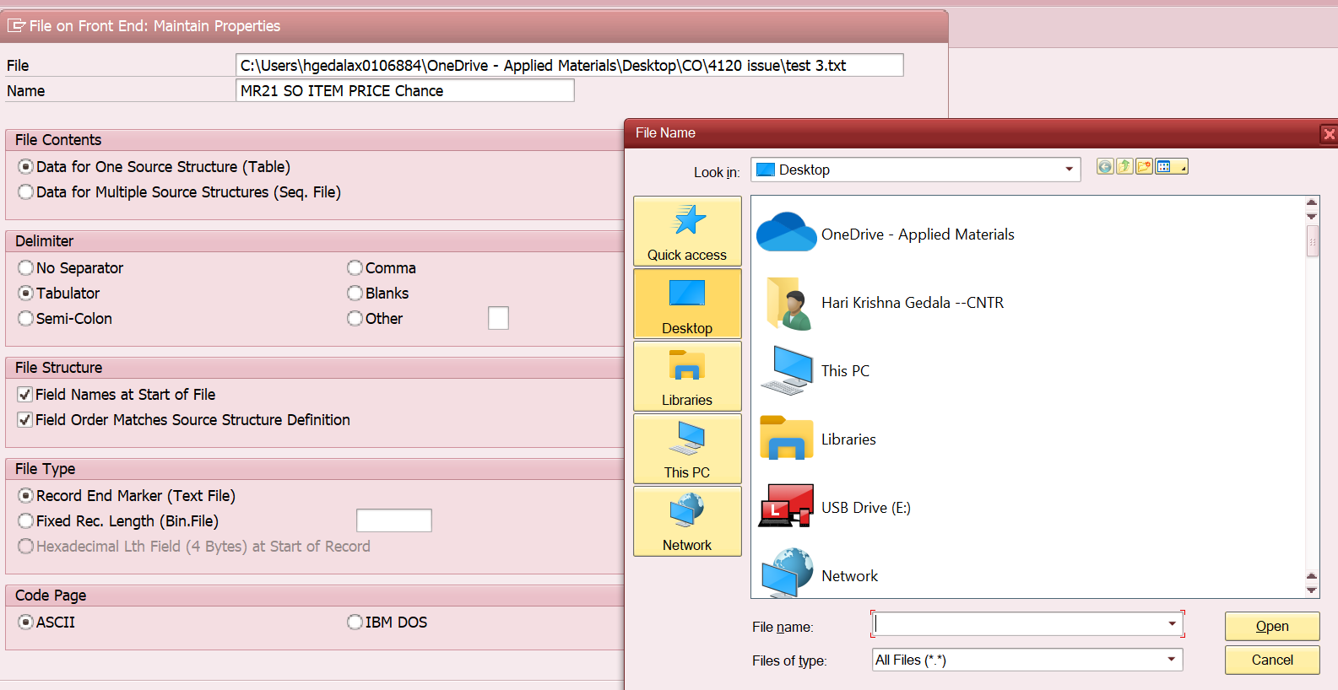
Enter
Save
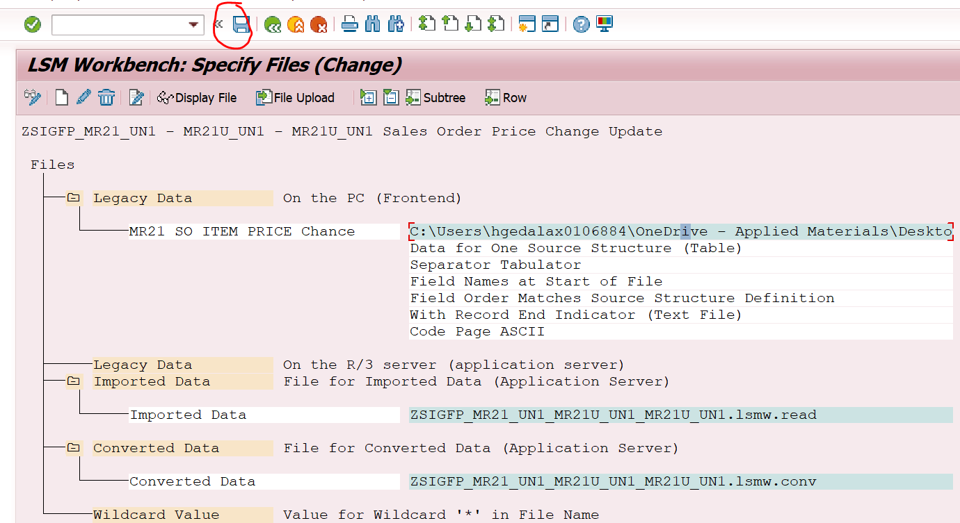
Come back
Select assign file and execute
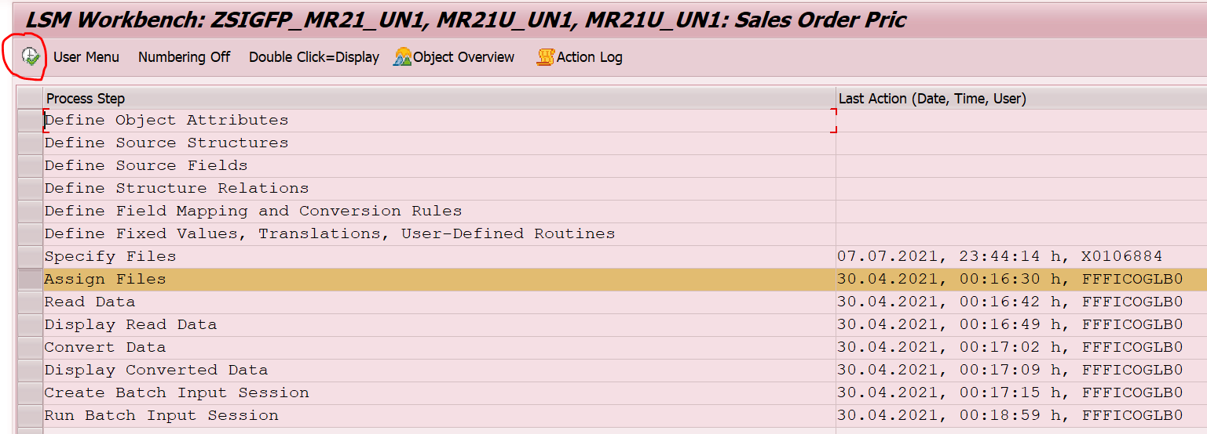
go to change mode and save as below
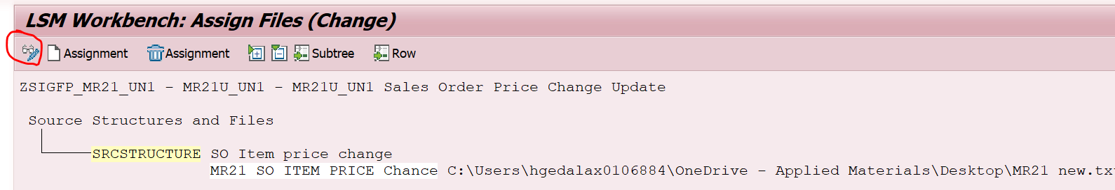
Come back
Select read data and execute
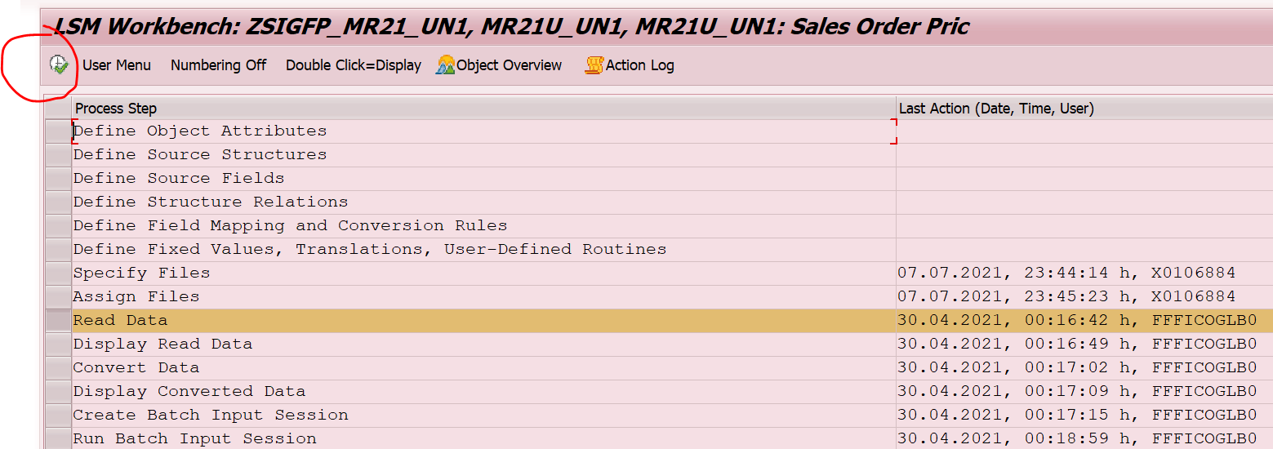
Execute and allow as below
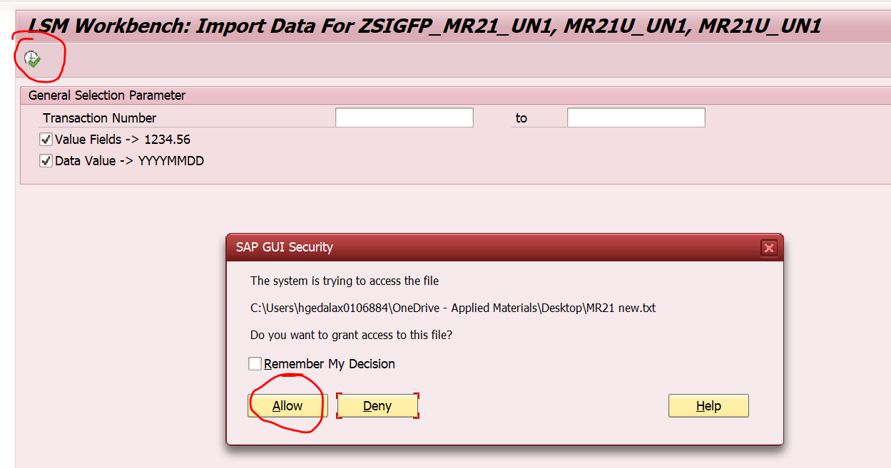
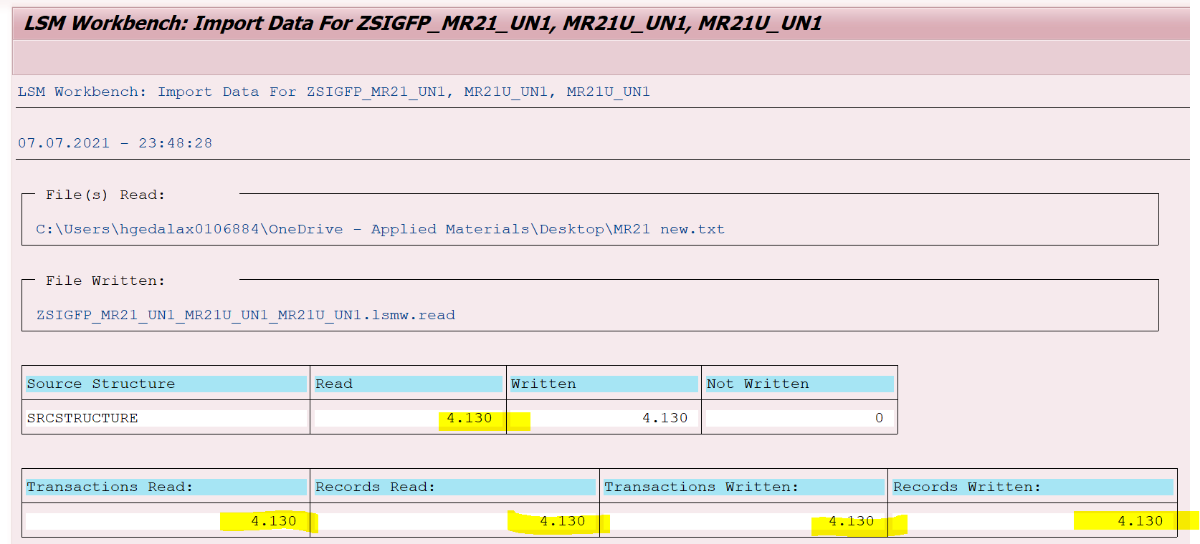
Verify the records with the uploaded file it should match
Come back’
Select display read data and execute
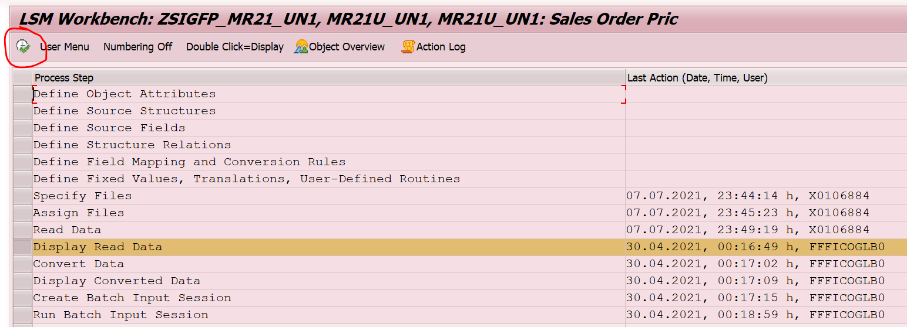
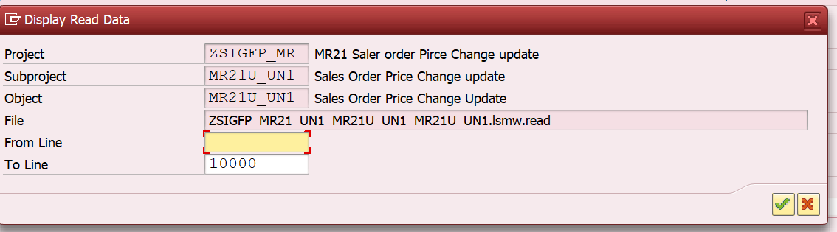
Enter
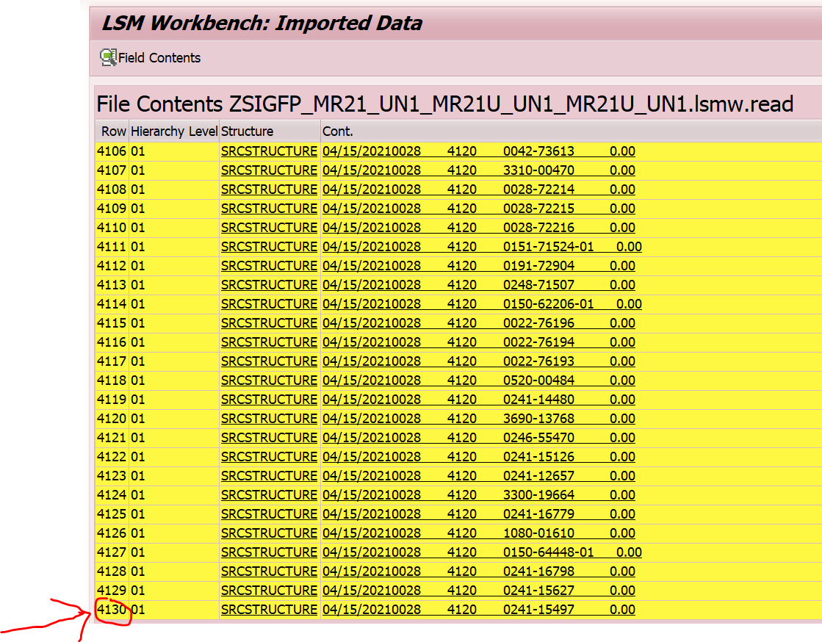
Records should matched
Come back
Select convert data and execute
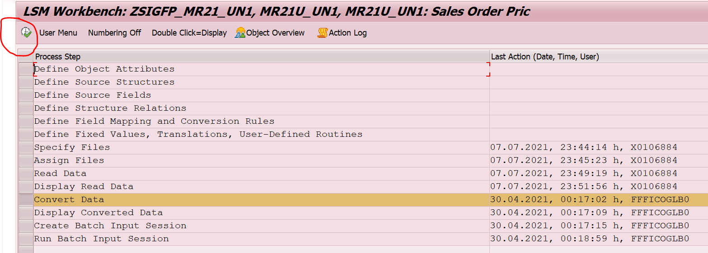
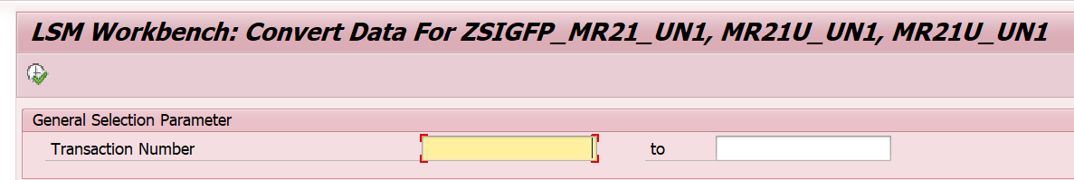
Execute
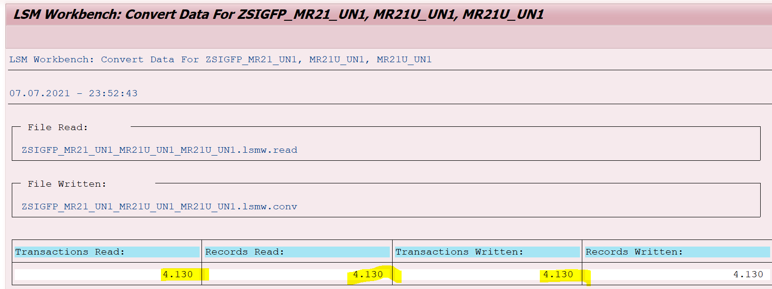
Records matched as above
Come back
Select display convert data and execute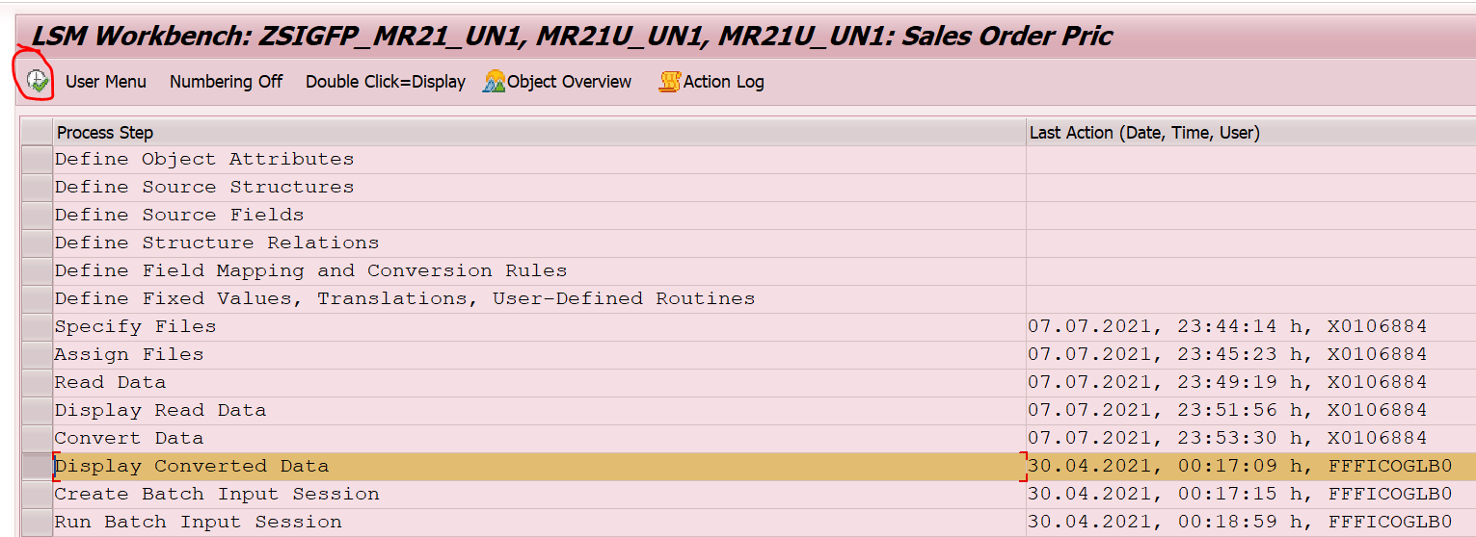
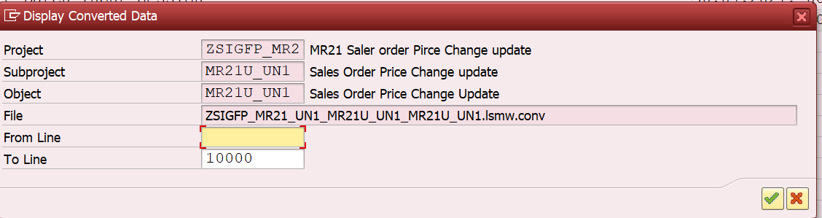
Enter
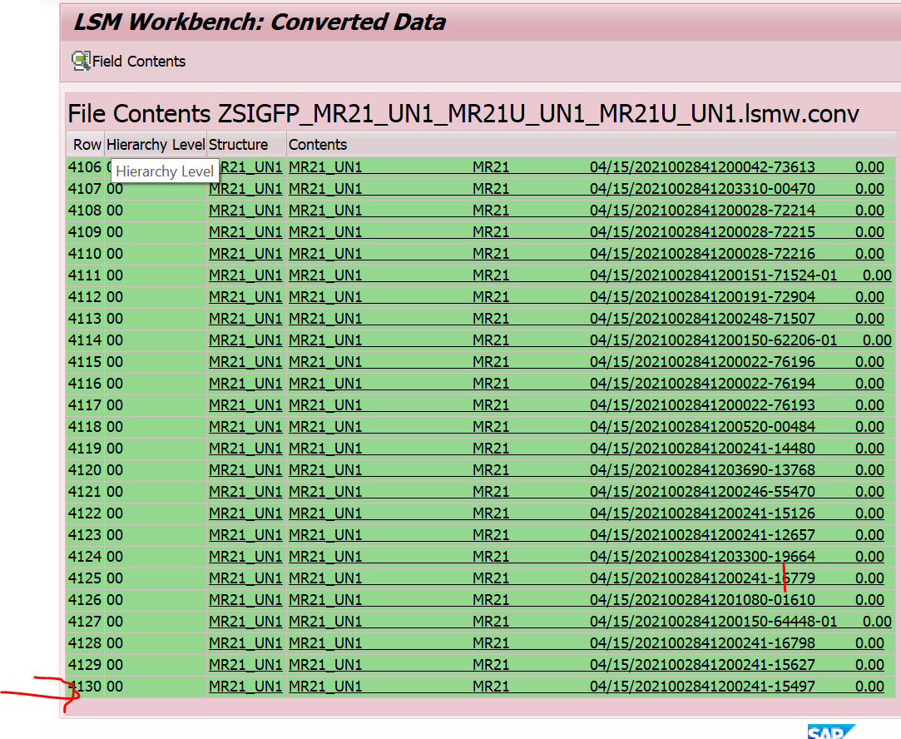
Records matched
Come back
Select Create Batch Input Session and execute
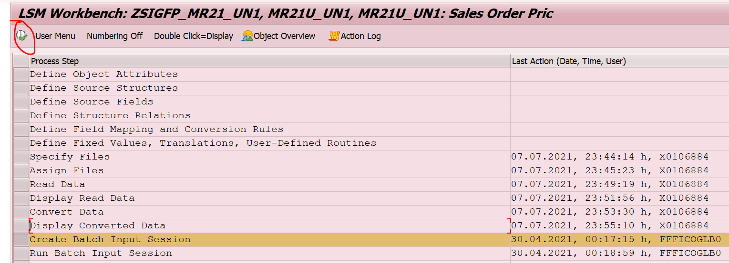
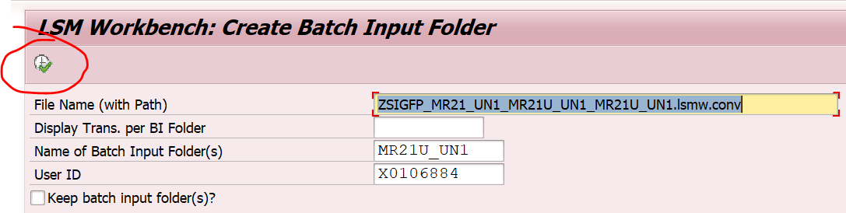
Execute
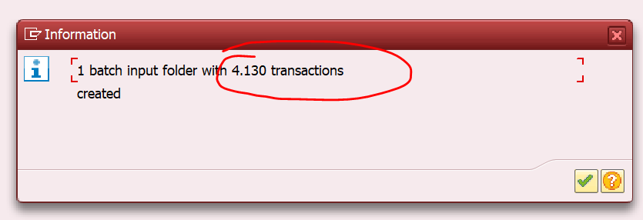
enter
Records matched
Select Run Batch Input Session and execute
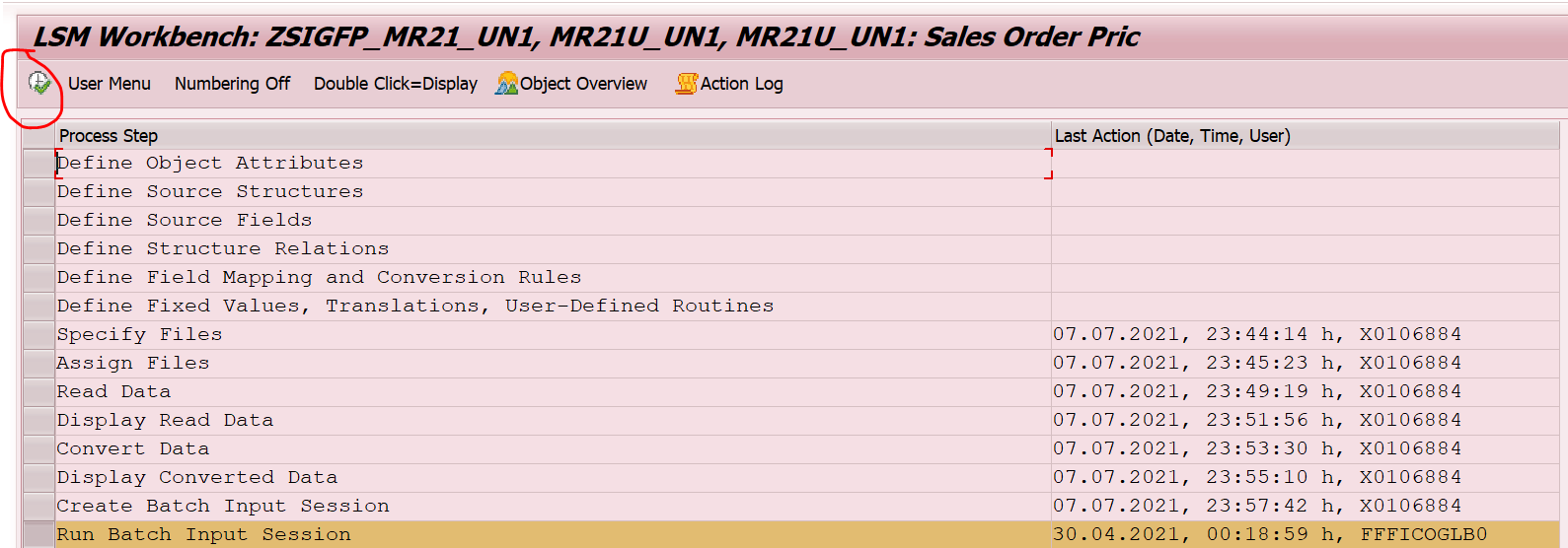
Select session name line and click on process
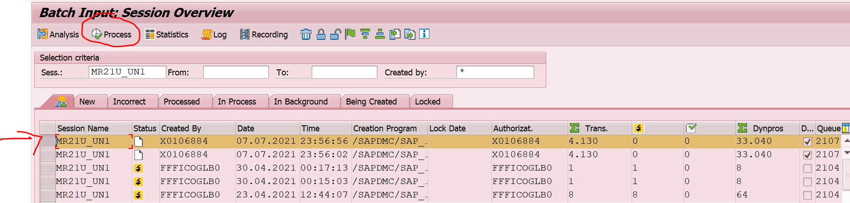
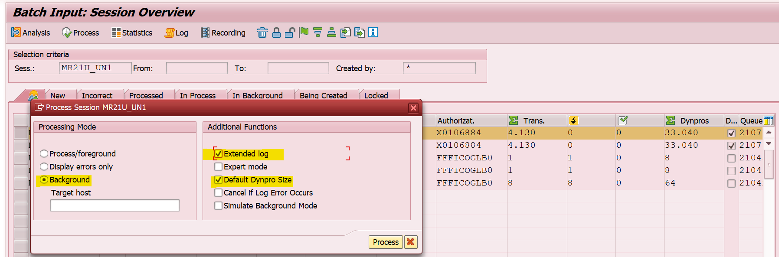
Select highlighted one and click on process
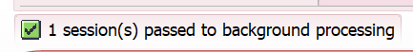
The above msg will displayed
Double click on below line, so we will get the updates of background running
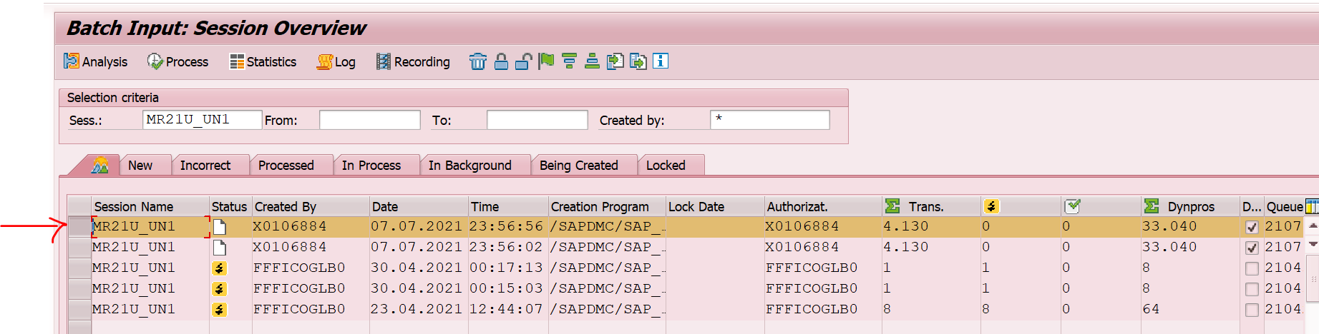

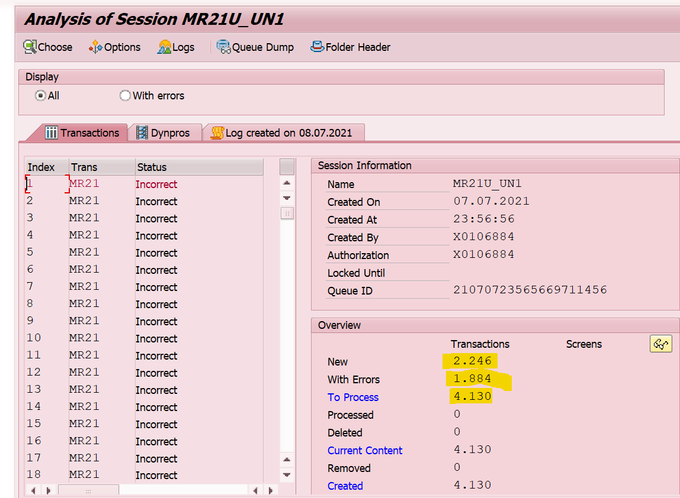
The above one is the records
Last step:
Go to MM03 for material and check current std price it should be deleted

